Supplementary material

Supplementary Table 1. Number of male infertility patients and age-standardized prevalence rate globally and regionally.

|  |  |  |  |  |  |  |  |
| --- | --- | --- | --- | --- | --- | --- | --- |
| Characteristics | | Age-standardised prevalence rate per 100,000 population | | | Prevalent cases | | |
| 1990 no (95% UI) | 2021 no (95% UI) | EAPC no (95% CI) | 1990 no (95% UI) | 2021 no (95% UI) | Percentage change (%) (95% UI) |
| Global | | 1158.86 (696.62–1858.35) | 1354.76 (802.12–2174.77) | 0.50 (0.36–0.64) | 31,490,381.81 (18,725,068.36–50,165,061.42) | 55,000,818.26 (32,611,257.30–88,727,953.05) | 74.66 (64.73–84.93) |
| SDI quintile | | | | | | | |
|  | High | 913.10 (540.97–1503.48) | 1071.23 (617.22–1766.67) | 0.63 (0.51–0.75) | 4,507,507.64 (2,671,002.26–7,483,431.80) | 5,890,821.25 (3,376,658.35–10,016,230.27) | 30.69 (21.79–38.70) |
| High middle | 1402.44 (813.39–2341.64) | 1472.79 (851.46–2414.28) | 0.13 (0.11–0.14) | 8,274,379.82 (4,805,665.44–13,829,973.39) | 10,194,898.83 (5,795,900.84–17,173,215.22) | 23.21 (12.41–35.46) |
| Middle | 1189.81 (698.93–1920.87) | 1387.96 (819.52–2230.90) | 0.60 (0.52–0.69) | 10,643,923.44 (6,194,862.20–17,124,721.74) | 18,151,666.39 (10,796,198.08–29,302,985.51) | 70.54 (56.96–83.44) |
| Low middle | 1019.46 (625.06–1572.81) | 1395.96 (813.30–2252.12) | 1.00 (0.59–1.41) | 5,483,315.94 (3,304,294.91–8,526,906.22) | 14,297,089.00 (8,370,702.13–22,875,418.18) | 160.74 (135.05–188.45) |
| Low | 1245.80 (798.69–1859.93) | 1269.37 (770.19–1959.84) | −0.17 (−0.46–0.13) | 2,553,100.13 (1,625,424.89–3,816,041.88) | 6,427,823.94 (3,885,081.58–9,979,635.42) | 151.77 (131.98–170.35) |
| GBD region | | | | | | | |
|  | Andean Latin America | 396.61 (290.98–521.42) | 655.75 (363.35–1142.51) | 2.14 (1.76–2.53) | 66,689.13 (48,788.25–88,478.74) | 232,367.43 (128,536.64–402,806.52) | 251.19 (122.17–458.71) |
| Australasia | 588.59 (332.02–995.27) | 622.98 (350.36–1073.96) | 0.25 (0.21–0.29) | 66,016.90 (37,612.50–110,358.48) | 94,399.26 (53,291.54–163,037.29) | 43.30 (32.13–53.76) |
| Caribbean | 1330.56 (857.61–2009.98) | 1331.15 (838.46–2090.09) | −0.09 (−0.20–0.01) | 231,262.66 (145,911.66–352,735.84) | 320,709.18 (202,004.82–504,649.28) | 39.97 (28.14–52.94) |
| Central Asia | 932.15 (558.25–1504.94) | 933.06 (541.89–1535.07) | 0.38 (0.23–0.53) | 317,276.26 (189,426.49–515,684.28) | 482,053.77 (278,126.69–809,038.34) | 52.94 (37.56–71.58) |
| Central Europe | 1192.22 (639.02–2009.25) | 1371.77 (748.40–2424.41) | 0.62 (0.51–0.74) | 772,588.76 (413,730.90–1,338,291.57) | 751,761.37 (408,846.04–1,337,048.57) | −2.27 (−11.21–8.43) |
| Central Latin America | 723.65 (439.50–1145.16) | 1049.57 (618.04–1736.39) | 0.51 (0.26–0.76) | 536,998.66 (324,075.61–851,370.71) | 1,366,956.42 (804,645.78–2,251,064.73) | 157.42 (128.08–189.17) |
| Central Sub-Saharan Africa | 1408.90 (825.74–2239.33) | 1411.72 (789.07–2271.46) | −0.38 (−0.81–0.05) | 303,906.71 (178,728.06–485,298.21) | 842,775.72 (472,132.45–1,354,803.64) | 177.63 (157.71–196.87) |
| East Asia | 1505.44 (828.85–2582.69) | 1575.70 (880.94–2675.46) | 0.00 (−0.05–0.06) | 10,509,539.43 (5,795,153.70–17,988,762.13) | 12,167,666.71 (6,670,101.31–21,239,730.50) | 16.42 (3.24–29.89) |
| Eastern Europe | 2048.71 (1134.63–3451.39) | 2058.13 (1120.20–3444.23) | 0.26 (0.15–0.37) | 2,436,821.09 (1,340,147.15–4,110,201.30) | 2,041,839.47 (1,134,417.15–3,432,078.04) | −15.94 (−24.20–−7.35) |
| Eastern Sub-Saharan Africa | 977.48 (625.39–1463.76) | 777.87 (459.72–1236.42) | −1.19 (−1.42–−0.95) | 717,199.91 (457,300.09–1,082,606.07) | 1,481,393.04 (872,091.08–2,357,012.68) | 107.32 (81.92–126.87) |
| High-income Asia Pacific | 954.64 (521.56–1618.01) | 898.57 (491.48–1481.48) | −0.20 (−0.30–−0.10) | 939,651.82 (506,916.38–1,612,719.95) | 797,761.17 (429,920.07–1,382,800.38) | −14.83 (−22.26–−8.07) |
| High-income North America | 786.35 (428.27–1313.71) | 1010.31 (546.66–1701.88) | 0.83 (0.16–1.50) | 1,259,675.53 (681,360.60–2,083,775.91) | 1,752,539.16 (954,878.39–2,959,534.53) | 38.91 (24.92–55.18) |
| North Africa and Middle East | 903.37 (616.17–1278.62) | 1154.32 (681.51–1863.21) | 0.80 (0.62–0.99) | 1,461,618.86 (988,197.39–2,118,152.47) | 4,150,567.41 (2,458,604.72–6,611,300.68) | 193.15 (131.89–257.30) |
| Oceania | 940.62 (546.36–1505.52) | 712.44 (498.04–1011.41) | −0.96 (−1.18–−0.74) | 28,943.38 (16,774.49–47,140.70) | 50,724.94 (35,213.44–72,463.58) | 75.56 (36.34–129.14) |
| South Asia | 991.39 (567.54–1611.73) | 1464.33 (835.34–2404.50) | 1.52 (0.93–2.12) | 5,354,172.36 (3,009,880.67–8,820,631.31) | 15,223,185.68 (8,656,105.04–25,000,575.41) | 190.58 (148.13–241.10) |
| Southeast Asia | 1048.85 (604.24–1714.31) | 1399.74 (805.71–2309.49) | 1.59 (1.29–1.89) | 2,384,426.03 (1,376,795.62–3,855,372.73) | 5,370,095.32 (3,092,324.24–8,839,732.11) | 128.48 (105.46–152.86) |
| Southern Latin America | 1016.39 (575.35–1727.87) | 1014.36 (577.04–1717.53) | −–0.05 (−0.13–0.03) | 242,927.56 (136,165.88–415,118.01) | 361,275.45 (206,015.37–615,642.42) | 49.06 (39.76–59.90) |
| Southern Sub-Saharan Africa | 1023.78 (592.99–1704.41) | 718.21 (382.24–1327.36) | −0.68 (−1.24–0.11) | 242,945.53 (138,827.45–396,822.79) | 320,675.98 (168,458.12–598,875.50) | 33.11 (7.10–63.98) |
| Tropical Latin America | 811.64 (467.99–1334.73) | 1110.32 (629.61–1860.19) | 1.83 (1.39–2.27) | 616,956.08 (342,573.68–1,048,655.46) | 1,384,604.10 (780,680.82–2,299,828.45) | 126.91 (93.43–167.93) |
| Western Europe | 759.86 (482.71–1159.86) | 972.43 (540.33–1653.86) | 0.95 (0.75–1.15) | 1,548,471.93 (985,968.19–2,357,811.37) | 1,933,592.21 (1,070,793.37–3,257,464.02) | 25.03 (5.10–40.24) |
| Western Sub-Saharan Africa | 1840.44 (1266.65–2640.41) | 1918.52 (1198.23–2948.44) | −0.62 (−0.89–0.34) | 1,452,293.24 (995,233.42–2,071,791.34) | 3,873,874.49 (2,374,489.46–5,892,117.49) | 168.09 (126.29–205.92) |

SDI: Socio-Demographic Index; GBD: Global Burden of Disease; EAPC: Estimated annual percentage change; UI: uncertainty interval; CI: confidence interval.

Supplementary Table 2. Age-standardized prevalence rate of male infertility in 204 countries and regions worldwide.

|  |  |  |  |
| --- | --- | --- | --- |
| Characteristics | Age-standardised prevalence rate per 100,000 population | | |
| 1990 no (95% UI) | 2021 no (95% UI) | EAPC no (95% CI) |
| Afghanistan | 793.73 (432.47–1317.15) | 585.09 (432.08–764.44) | −1.39 (−1.66–−1.12) |
| Albania | 953.99 (521.75–1693.42) | 669.86 (491.43–917.98) | −1.18 (−1.89–−0.46) |
| Algeria | 675.91 (431.99–953.72) | 1013.95 (565.16–1647.28) | 1.78 (1.54–2.02) |
| American Samoa | 1092.01 (627.79–1766.09) | 1085.20 (612.04–1747.87) | −0.03 (−0.04–−0.02) |
| Andorra | 834.35 (453.44–1384.31) | 824.60 (435.71–1363.30) | −0.04 (−0.07–−0.02) |
| Angola | 1804.18 (1036.17–2894.84) | 1800.68 (1017.65–2952.35) | 0.01 (−0.02–0.04) |
| Antigua and Barbuda | 1512.60 (850.47–2486.03) | 1505.75 (851.09–2451.31) | −0.01 (−0.02–−0.00) |
| Argentina | 1012.34 (570.94–1727.53) | 1022.31 (583.47–1729.93) | −0.03 (−0.11–0.06) |
| Armenia | 961.69 (507.74–1716.86) | 431.14 (302.62–600.38) | −1.93 (−2.26–−1.59) |
| Australia | 577.08 (327.42–976.21) | 566.75 (318.15–969.69) | −0.06 (−0.12–−0.01) |
| Austria | 1630.08 (919.48–2718.29) | 1622.47 (907.62–2710.60) | 0.75 (0.46–1.05) |
| Azerbaijan | 1278.52 (710.45–2203.04) | 1271.84 (709.26–2129.58) | −0.39 (−1.24–0.47) |
| Bahamas | 1554.27 (868.67–2610.19) | 1526.59 (873.90–2552.71) | −0.04 (−0.05–−0.03) |
| Bahrain | 1103.55 (631.38–1763.77) | 1104.98 (635.05–1815.74) | 0.01 (−0.00–0.01) |
| Bangladesh | 604.00 (449.12–797.59) | 741.06 (554.73–981.89) | 0.85 (0.52–1.17) |
| Barbados | 1511.54 (857.83–2466.50) | 1502.12 (851.23–2491.66) | −0.00 (−0.02–0.01) |
| Belarus | 1435.67 (793.05–2466.56) | 1426.76 (798.91–2445.33) | −0.01 (−0.02–−0.01) |
| Belgium | 930.99 (681.68–1291.22) | 1443.21 (797.50–2320.80) | 1.54 (1.10–1.99) |
| Belize | 720.87 (513.44–992.57) | 942.42 (534.24–1544.25) | 0.99 (0.71–1.28) |
| Benin | 1711.12 (986.75–2794.59) | 1115.31 (826.91–1471.57) | −1.27 (−1.34–−1.20) |
| Bermuda | 1507.80 (850.63–2507.03) | 1503.38 (851.36–2490.79) | 0.00 (−0.01–0.01) |
| Bhutan | 725.10 (423.27–1183.84) | 699.68 (409.08–1141.15) | −0.10 (−0.12–−0.09) |
| Bolivia (Plurinational State of) | 497.61 (367.33–657.03) | 617.82 (343.90–1046.34) | 1.39 (0.68–2.09) |
| Bosnia and Herzegovina | 1049.97 (544.94–1844.07) | 1028.50 (535.53–1769.41) | −0.05 (−0.06–−0.03) |
| Botswana | 506.27 (368.10–687.14) | 793.34 (411.81–1460.55) | 0.48 (0.14–0.82) |
| Brazil | 811.61 (464.59–1343.36) | 1106.42 (626.91–1857.81) | 1.84 (1.39–2.30) |
| Brunei Darussalam | 677.42 (371.42–1172.57) | 658.79 (359.22–1143.25) | −0.09 (−0.18–0.01) |
| Bulgaria | 1054.85 (550.77–1881.10) | 1050.82 (550.05–1830.74) | −0.01 (−0.02–−0.00) |
| Burkina Faso | 1671.91 (1274.31–2176.38) | 1637.74 (951.28–2682.60) | −0.73 (−1.26–−0.19) |
| Burundi | 565.36 (409.11–752.39) | 286.34 (210.07–378.98) | −2.34 (−2.80–−1.88) |
| Cabo Verde | 2204.36 (1281.44–3496.70) | 2173.28 (1263.58–3422.38) | −0.03 (−0.04–−0.02) |
| Cambodia | 997.53 (548.79–1759.23) | 969.59 (544.24–1676.42) | −1.75 (−2.45–−1.04) |
| Cameroon | 2911.18 (2186.03–3780.19) | 3280.58 (1939.56–5141.30) | −0.46 (−1.30–0.39) |
| Canada | 638.27 (346.10–1092.88) | 633.56 (344.26–1052.91) | −0.03 (−0.06–0.00) |
| Central African Republic | 2273.19 (1719.99–2887.93) | 2803.40 (1618.38–4341.94) | 0.72 (0.52–0.93) |
| Chad | 2129.00 (1202.75–3524.00) | 2129.96 (1188.81–3548.28) | −2.63 (−3.34–−1.91) |
| Chile | 1026.35 (576.26–1743.50) | 997.51 (555.17–1695.30) | −0.10 (−0.18–−0.03) |
| China | 1517.39 (834.93–2599.79) | 1591.79 (886.51–2708.22) | 0.01 (−0.05–0.06) |
| Colombia | 382.11 (283.71–508.16) | 397.86 (299.24–531.64) | 0.29 (0.11–0.47) |
| Comoros | 1748.36 (1014.60–2815.92) | 1736.17 (970.50–2811.95) | 0.89 (0.37–1.41) |
| Congo | 1395.66 (763.36–2347.56) | 1387.03 (773.98–2332.26) | −0.63 (−1.17–−0.08) |
| Cook Islands | 1033.73 (583.01–1651.50) | 1035.22 (597.82–1686.39) | −0.00 (−0.02–0.02) |
| Costa Rica | 1063.16 (586.63–1836.93) | 1055.45 (590.51–1782.78) | −0.04 (−0.05–−0.04) |
| Croatia | 1054.91 (545.74–1891.36) | 1055.15 (552.84–1818.32) | −0.01 (−0.02–−0.01) |
| Cuba | 1513.01 (854.36–2504.24) | 1498.58 (851.33–2494.68) | 0.01 (−0.00–0.03) |
| Cyprus | 844.82 (462.80–1429.15) | 829.66 (440.59–1407.67) | −0.08 (−0.11–−0.06) |
| Czechia | 1413.17 (745.80–2492.99) | 1409.93 (749.96–2463.73) | 1.11 (0.67–1.54) |
| Côte d’Ivoire | 1804.47 (1371.31–2347.93) | 2643.52 (1568.36–4217.07) | 0.81 (0.36–1.25) |
| Democratic People’s Republic of Korea | 1127.12 (626.68–1928.89) | 1160.20 (643.73–2041.90) | 0.04 (0.01–0.07) |
| Democratic Republic of the Congo | 1199.82 (671.59–1959.62) | 1189.35 (661.73–1932.69) | −0.76 (−1.63–0.12) |
| Denmark | 298.36 (190.43–446.05) | 450.55 (224.47–795.74) | 1.48 (1.01–1.94) |
| Djibouti | 1771.54 (1018.23–2894.51) | 1777.91 (1027.08–2864.62) | 0.28 (−0.20–0.77) |
| Dominica | 1523.07 (877.80–2534.00) | 1519.64 (869.20–2519.88) | 0.01 (−0.00–0.02) |
| Dominican Republic | 717.59 (546.35–937.40) | 1280.27 (731.51–2179.92) | 1.34 (0.58–2.10) |
| Ecuador | 470.00 (342.38–626.14) | 632.06 (351.73–1065.90) | 2.18 (1.61–2.76) |
| Egypt | 539.42 (450.31–639.28) | 833.05 (466.77–1349.87) | 0.92 (0.57–1.27) |
| El Salvador | 485.09 (350.66–668.92) | 586.90 (321.39–1022.60) | 1.95 (1.14–2.78) |
| Equatorial Guinea | 1827.70 (1038.41–2961.62) | 1752.89 (995.23–2833.08) | −0.16 (−0.18–−0.15) |
| Eritrea | 1036.39 (764.74–1353.11) | 1530.45 (858.31–2498.82) | 1.64 (1.44–1.84) |
| Estonia | 1431.37 (792.09–2411.28) | 1434.74 (783.60–2474.49) | 0.01 (0.00–0.02) |
| Eswatini | 578.94 (310.72–1010.21) | 569.24 (299.16–1007.21) | −0.39 (−1.16–0.38) |
| Ethiopia | 1290.53 (740.45–2123.12) | 808.78 (451.22–1324.26) | −1.07 (−1.28–−0.87) |
| Fiji | 1490.79 (845.20–2413.04) | 1505.91 (877.88–2366.25) | 0.02 (0.01–0.04) |
| Finland | 272.59 (208.91–354.32) | 536.25 (274.41–906.12) | 1.05 (0.56–1.53) |
| France | 754.36 (550.82–999.14) | 1182.59 (639.37–2003.82) | 1.57 (1.09–2.05) |
| Gabon | 2208.65 (1247.12–3596.84) | 2151.79 (1242.99–3432.98) | 0.14 (−0.26–0.54) |
| Gambia | 2213.92 (1285.02–3455.34) | 2223.41 (1321.41–3469.27) | −0.52 (−0.83–−0.20) |
| Georgia | 1043.53 (573.19–1791.99) | 1039.13 (573.63–1803.86) | −0.03 (−0.04–−0.02) |
| Germany | 335.06 (224.32–494.35) | 533.61 (280.06–944.23) | 1.59 (1.12–2.06) |
| Ghana | 1511.82 (1333.96–1706.39) | 2264.66 (1305.25–3685.48) | −0.16 (−0.66–0.34) |
| Greece | 836.05 (448.86–1386.15) | 828.79 (433.80–1420.68) | −0.04 (−0.07–−0.01) |
| Greenland | 652.21 (355.90–1085.70) | 638.60 (343.03–1056.92) | −0.09 (−0.13–−0.06) |
| Grenada | 1539.22 (871.03–2504.11) | 1546.13 (869.85–2566.14) | 0.01 (−0.01–0.03) |
| Guam | 1058.26 (613.09–1705.32) | 1080.05 (616.20–1738.58) | 0.05 (0.04–0.07) |
| Guatemala | 700.17 (522.32–923.29) | 947.41 (516.05–1619.18) | −0.47 (−1.16–0.23) |
| Guinea | 2798.32 (1627.18–4543.56) | 2048.65 (1516.62–2683.14) | −0.79 (−0.90–−0.68) |
| Guinea-Bissau | 2297.93 (1314.66–3780.47) | 2273.99 (1302.62–3689.93) | −0.01 (−0.02–0.01) |
| Guyana | 2026.82 (1170.74–3300.48) | 2014.24 (1156.20–3260.91) | −0.35 (−1.09–0.39) |
| Haiti | 1280.29 (946.30–1662.41) | 1016.85 (752.44–1324.30) | −0.41 (−0.57–−0.24) |
| Honduras | 980.39 (534.75–1712.14) | 967.91 (525.44–1646.92) | 0.30 (−0.76–1.36) |
| Hungary | 1036.10 (532.02–1809.09) | 1044.86 (542.26–1825.88) | 0.01 (−0.01–0.02) |
| Iceland | 840.47 (456.25–1396.88) | 834.57 (438.59–1399.57) | −0.03 (−0.06–−0.01) |
| India | 954.95 (542.40–1579.69) | 1516.62 (872.42–2491.07) | 2.03 (1.52–2.55) |
| Indonesia | 1331.29 (752.17–2197.57) | 1939.83 (1128.75–3179.61) | 1.43 (0.96–1.90) |
| Iran (Islamic Republic of) | 1253.34 (665.50–2159.79) | 1267.29 (668.74–2212.22) | −0.14 (−0.66–0.37) |
| Iraq | 1117.20 (639.98–1781.87) | 1112.42 (634.49–1802.09) | 0.00 (−0.01–0.02) |
| Ireland | 833.05 (436.51–1406.28) | 818.90 (434.66–1391.97) | −0.06 (−0.10–−0.03) |
| Israel | 1175.92 (656.92–1943.74) | 1217.99 (648.36–2068.65) | 0.07 (−0.03–0.17) |
| Italy | 932.50 (505.03–1635.16) | 1325.59 (731.69–2306.54) | 1.39 (1.10–1.67) |
| Jamaica | 1772.64 (1020.78–2902.90) | 1767.87 (1021.65–2865.60) | 0.02 (0.00–0.03) |
| Japan | 1065.16 (585.98–1833.51) | 1040.13 (565.18–1732.58) | −0.11 (−0.21–−0.02) |
| Jordan | 567.00 (364.12–824.35) | 944.05 (691.26–1287.07) | 1.13 (0.89–1.38) |
| Kazakhstan | 773.37 (554.46–1065.97) | 1022.13 (566.92–1753.78) | 1.79 (1.36–2.23) |
| Kenya | 714.49 (404.36–1194.40) | 957.26 (537.89–1633.13) | −2.59 (−3.78–−1.38) |
| Kiribati | 1078.65 (622.27–1728.59) | 1064.75 (607.78–1723.37) | −0.02 (−0.03–−0.01) |
| Kuwait | 1120.52 (630.90–1834.19) | 1119.75 (633.65–1808.15) | 0.02 (0.01–0.03) |
| Kyrgyzstan | 1250.48 (705.82–2093.95) | 1251.82 (709.87–2121.36) | 0.30 (−0.13–0.74) |
| Lao People’s Democratic Republic | 894.96 (499.26–1520.74) | 885.62 (496.59–1488.89) | 0.01 (−0.01–0.03) |
| Latvia | 985.54 (718.01–1342.09) | 1458.48 (794.22–2510.50) | 1.79 (1.43–2.15) |
| Lebanon | 1383.08 (792.22–2205.82) | 1379.03 (808.81–2210.39) | 1.35 (0.86–1.83) |
| Lesotho | 1027.35 (562.62–1759.67) | 1025.55 (566.90–1750.15) | −2.24 (−3.32–−1.15) |
| Liberia | 2640.68 (1998.37–3426.84) | 2804.10 (1612.32–4491.78) | −0.66 (−1.16–−0.15) |
| Libya | 730.60 (465.88–1044.13) | 1022.64 (571.40–1625.81) | 1.48 (1.19–1.78) |
| Lithuania | 986.08 (705.06–1355.37) | 1461.14 (805.31–2563.38) | 1.73 (1.39–2.08) |
| Luxembourg | 848.76 (461.17–1405.40) | 830.98 (442.67–1394.71) | −0.08 (−0.11–−0.04) |
| Madagascar | 810.53 (591.52–1058.95) | 1042.23 (596.05–1699.28) | 0.76 (0.12–1.40) |
| Malawi | 1174.70 (841.76–1577.28) | 297.57 (209.93–401.32) | −4.22 (−4.56–−3.88) |
| Malaysia | 780.19 (451.99–1338.82) | 829.28 (461.20–1436.99) | 0.20 (0.13–0.27) |
| Maldives | 1837.26 (1068.04–2979.91) | 1459.44 (1109.85–1890.73) | −1.14 (−1.59–−0.68) |
| Mali | 2274.66 (1753.70–2906.86) | 1476.27 (1112.90–1937.96) | −1.33 (−1.68–−0.98) |
| Malta | 842.13 (443.76–1409.27) | 833.30 (438.53–1394.59) | −0.05 (−0.08–−0.02) |
| Marshall Islands | 1091.69 (626.59–1771.59) | 1085.85 (624.85–1753.29) | 0.00 (−0.01–0.01) |
| Mauritania | 1650.59 (1103.80–2237.87) | 2707.04 (1625.71–4341.97) | 1.66 (1.46–1.86) |
| Mauritius | 875.89 (479.58–1501.49) | 858.68 (472.23–1450.60) | −0.05 (−0.06–−0.04) |
| Mexico | 784.98 (437.39–1305.75) | 1384.45 (784.55–2354.71) | 0.69 (0.27–1.12) |
| Micronesia (Federated States of) | 1105.65 (636.55–1786.36) | 1085.67 (634.42–1736.56) | −0.05 (−0.06–−0.04) |
| Monaco | 837.74 (450.64–1429.56) | 823.83 (440.46–1389.29) | −0.07 (−0.10–−0.04) |
| Mongolia | 959.29 (566.11–1627.87) | 1039.15 (585.92–1779.07) | 0.27 (0.19–0.35) |
| Montenegro | 1046.63 (546.06–1842.27) | 1035.01 (546.97–1762.60) | −0.02 (−0.03–−0.01) |
| Morocco | 805.75 (605.67–1048.37) | 1322.62 (743.02–2155.35) | 2.79 (1.93–3.65) |
| Mozambique | 1530.38 (861.16–2570.23) | 1473.73 (830.14–2404.03) | −1.19 (−1.82–−0.56) |
| Myanmar | 933.58 (521.80–1691.16) | 564.13 (421.63–743.11) | −2.29 (−2.72–−1.85) |
| Namibia | 603.11 (446.86–801.13) | 612.00 (327.93–1101.72) | −0.91 (−2.01–0.21) |
| Nauru | 1059.01 (609.63–1689.11) | 1056.65 (592.65–1720.19) | −0.02 (−0.03–−0.01) |
| Nepal | 838.86 (499.05–1382.62) | 475.37 (350.54–629.31) | −0.83 (−1.51–−0.15) |
| Netherlands | 827.11 (447.20–1408.02) | 821.89 (429.87–1394.52) | −0.01 (−0.04–0.02) |
| New Zealand | 646.08 (356.64–1116.85) | 897.58 (497.25–1540.71) | 1.47 (1.20–1.74) |
| Nicaragua | 659.63 (364.25–1130.15) | 646.76 (352.63–1114.98) | 1.47 (0.77–2.17) |
| Niger | 2660.45 (1964.61–3414.34) | 2153.52 (1270.90–3422.11) | −1.10 (−1.64–−0.55) |
| Nigeria | 1606.70 (933.72–2583.32) | 1550.97 (890.03–2503.50) | −0.96 (−1.30–−0.62) |
| Niue | 1036.70 (591.24–1666.16) | 1039.48 (583.00–1684.54) | 0.00 (−0.02–0.02) |
| North Macedonia | 1038.98 (543.85–1810.44) | 1028.77 (535.62–1776.31) | −0.01 (−0.02–0.01) |
| Northern Mariana Islands | 1079.26 (620.02–1705.68) | 1064.50 (607.57–1707.35) | −0.03 (−0.04–−0.02) |
| Norway | 1333.31 (718.34–2314.32) | 1319.64 (719.51–2260.11) | −0.06 (−0.10–−0.03) |
| Oman | 1098.45 (618.29–1785.52) | 1101.38 (634.23–1768.64) | 0.02 (0.01–0.03) |
| Pakistan | 1718.87 (655.31–3406.67) | 1735.86 (602.15–3629.48) | −3.46 (−6.49–−0.33) |
| Palau | 1041.61 (596.01–1679.22) | 1037.84 (576.22–1660.38) | 0.01 (−0.00–0.02) |
| Palestine | 1109.79 (628.23–1785.44) | 1106.37 (639.04–1763.44) | −0.02 (−0.03–−0.01) |
| Panama | 1185.48 (661.63–2008.83) | 1155.84 (644.44–1996.73) | −0.06 (−0.07–−0.06) |
| Papua New Guinea | 786.45 (450.44–1281.25) | 572.11 (415.45–779.24) | −1.12 (−1.45–−0.80) |
| Paraguay | 821.18 (607.62–1097.07) | 1243.90 (692.19–1989.80) | 1.54 (1.10–1.99) |
| Peru | 333.53 (246.71–440.97) | 679.27 (368.53–1223.92) | 2.33 (1.87–2.79) |
| Philippines | 1682.94 (696.23–3087.13) | 1968.48 (817.08–3700.04) | 5.33 (3.18–7.53) |
| Poland | 1464.55 (804.67–2490.32) | 1921.05 (1065.25–3372.64) | 0.97 (0.69–1.25) |
| Portugal | 789.57 (420.95–1323.19) | 779.16 (410.03–1327.82) | −0.06 (−0.09–−0.03) |
| Puerto Rico | 1509.94 (848.22–2523.54) | 1503.71 (852.69–2473.60) | 0.01 (−0.01–0.02) |
| Qatar | 1105.25 (631.19–1771.50) | 1102.31 (619.03–1776.68) | 0.01 (−0.01–0.02) |
| Republic of Korea | 697.08 (379.36–1178.02) | 657.20 (355.47–1134.32) | −0.18 (−0.28–−0.07) |
| Republic of Moldova | 1564.65 (883.77–2599.95) | 1589.69 (889.67–2663.40) | 0.86 (0.11–1.61) |
| Romania | 1061.11 (544.07–1835.64) | 1063.13 (552.33–1886.81) | −0.04 (−0.06–−0.02) |
| Russian Federation | 2171.13 (1195.99–3632.18) | 2155.70 (1178.35–3631.64) | −0.02 (−0.03–−0.01) |
| Rwanda | 664.37 (489.78–878.67) | 801.84 (458.06–1355.73) | −1.34 (−1.87–−0.80) |
| Saint Kitts and Nevis | 1507.65 (857.65–2440.57) | 1519.10 (845.47–2533.08) | 0.01 (−0.01–0.02) |
| Saint Lucia | 1531.51 (872.64–2537.00) | 1537.07 (857.59–2549.45) | −0.01 (−0.03–0.01) |
| Saint Vincent and the Grenadines | 1524.01 (868.79–2495.06) | 1543.06 (862.78–2550.31) | −0.00 (−0.02–0.01) |
| Samoa | 1068.24 (610.72–1726.25) | 1052.56 (607.36–1717.00) | −0.04 (−0.05–−0.03) |
| San Marino | 837.38 (453.56–1413.35) | 823.98 (433.85–1406.69) | −0.06 (−0.08–−0.03) |
| Sao Tome and Principe | 1267.84 (737.82–2088.21) | 1262.67 (725.14–2068.36) | −0.20 (−0.66–0.26) |
| Saudi Arabia | 1099.86 (624.94–1775.28) | 1100.83 (634.34–1765.58) | 0.01 (−0.01–0.02) |
| Senegal | 2052.94 (1589.05–2631.65) | 1704.89 (1300.51–2210.91) | −0.39 (−0.71–−0.07) |
| Serbia | 1040.55 (545.02–1822.19) | 1030.32 (535.47–1769.06) | 0.02 (0.01–0.04) |
| Seychelles | 865.75 (488.75–1504.44) | 857.00 (484.56–1487.68) | 0.04 (0.02–0.06) |
| Sierra Leone | 2493.19 (1429.38–3997.15) | 2472.82 (1436.00–4038.42) | −0.86 (−1.34–−0.38) |
| Singapore | 691.40 (376.50–1189.10) | 671.48 (365.23–1177.17) | −0.13 (−0.25–−0.02) |
| Slovakia | 1041.34 (533.29–1837.74) | 1037.08 (544.37–1824.02) | −0.04 (−0.05–−0.02) |
| Slovenia | 387.47 (262.96–576.01) | 707.08 (345.78–1339.98) | 2.73 (2.19–3.28) |
| Solomon Islands | 1117.82 (643.95–1784.02) | 1107.15 (634.02–1784.96) | −0.04 (−0.06–−0.02) |
| Somalia | 964.41 (529.07–1634.64) | 962.85 (544.73–1607.91) | −0.04 (−0.05–−0.03) |
| South Africa | 1168.12 (648.83–1991.11) | 722.59 (377.22–1360.38) | −0.70 (−1.40–0.01) |
| South Sudan | 1002.39 (558.31–1698.17) | 990.59 (556.33–1667.32) | −0.11 (−0.13–−0.08) |
| Spain | 338.94 (234.20–465.57) | 561.47 (300.35–972.52) | 2.23 (1.81–2.65) |
| Sri Lanka | 481.90 (355.55–644.63) | 722.34 (406.77–1204.21) | 0.50 (0.20–0.80) |
| Sudan | 1833.55 (1397.20–2328.11) | 2455.48 (1457.20–3947.53) | 1.67 (1.27–2.07) |
| Suriname | 1509.56 (862.21–2491.28) | 1511.69 (857.56–2537.77) | −0.01 (−0.02–0.01) |
| Sweden | 1330.97 (721.42–2265.66) | 1343.91 (725.39–2286.74) | −0.03 (−0.06–0.00) |
| Switzerland | 846.42 (456.81–1411.44) | 826.04 (438.60–1389.73) | −0.07 (−0.10–−0.03) |
| Syrian Arab Republic | 716.17 (446.61–999.82) | 1024.34 (582.80–1652.28) | 1.71 (1.31–2.11) |
| Taiwan (Province of China) | 1159.25 (627.12–2007.09) | 1139.03 (631.81–1946.01) | −0.05 (−0.07–−0.03) |
| Tajikistan | 883.34 (499.57–1530.70) | 554.83 (415.53–750.94) | −1.74 (−2.03–−1.44) |
| Thailand | 533.65 (399.20–708.55) | 807.69 (442.67–1314.54) | 0.43 (0.11–0.76) |
| Timor-Leste | 724.31 (418.49–1174.53) | 723.28 (408.05–1174.29) | −0.22 (−0.69–0.25) |
| Togo | 1278.76 (947.34–1708.13) | 1854.41 (1088.48–3038.52) | 0.23 (−0.19–0.66) |
| Tokelau | 1066.65 (615.20–1702.37) | 1050.32 (596.57–1706.06) | −0.04 (−0.05–−0.03) |
| Tonga | 1034.65 (587.11–1647.99) | 1039.51 (587.05–1694.60) | 0.01 (−0.01–0.03) |
| Trinidad and Tobago | 1231.58 (923.96–1665.15) | 1733.57 (974.88–2846.91) | 0.42 (0.17–0.68) |
| Tunisia | 770.97 (561.15–1070.88) | 1083.82 (605.57–1753.84) | 1.48 (1.32–1.65) |
| Turkmenistan | 1047.24 (576.93–1854.61) | 1040.96 (577.09–1805.05) | −0.01 (−0.02–−0.00) |
| Tuvalu | 1059.62 (612.49–1712.15) | 1052.97 (594.71–1696.20) | −0.02 (−0.03–−0.01) |
| Türkiye | 629.23 (440.79–864.94) | 1062.00 (582.08–1734.84) | 0.31 (−0.21–0.84) |
| Uganda | 836.25 (623.45–1083.67) | 358.47 (256.78–476.16) | −3.10 (−3.36–−2.84) |
| Ukraine | 1983.58 (1048.47–3423.21) | 1995.24 (1068.39–3407.16) | 1.25 (0.73–1.77) |
| United Arab Emirates | 1097.32 (622.29–1764.03) | 1098.50 (628.34–1777.85) | 0.02 (0.01–0.03) |
| United Kingdom | 1234.68 (680.91–2078.07) | 1236.77 (666.70–2167.36) | −0.02 (−0.06–0.02) |
| United Republic of Tanzania | 572.92 (396.90–778.94) | 365.37 (262.73–501.34) | −1.49 (−1.77–−1.22) |
| United States of America | 802.73 (435.90–1341.46) | 1052.16 (569.10–1779.05) | 0.89 (0.17–1.62) |
| United States Virgin Islands | 1543.23 (880.86–2552.96) | 1518.59 (868.61–2547.66) | −0.05 (−0.06–−0.03) |
| Uruguay | 1015.87 (575.79–1742.06) | 998.80 (558.52–1689.03) | −0.06 (−0.13–0.00) |
| Uzbekistan | 831.06 (459.87–1402.61) | 830.77 (471.44–1400.43) | 0.84 (0.52–1.17) |
| Vanuatu | 1088.76 (623.46–1759.46) | 1105.65 (635.57–1791.40) | 0.03 (0.01–0.05) |
| Venezuela (Bolivarian Republic of) | 967.26 (539.43–1618.88) | 950.20 (522.03–1610.20) | −0.06 (−0.07–−0.05) |
| Viet Nam | 461.18 (253.61–780.59) | 442.40 (249.91–761.02) | 1.55 (0.96–2.13) |
| Yemen | 1291.51 (752.94–2090.42) | 1505.89 (864.64–2416.56) | 0.25 (−0.43–0.93) |
| Zambia | 979.30 (715.96–1289.19) | 798.09 (433.91–1346.21) | −2.48 (−3.32–−1.64) |
| Zimbabwe | 527.39 (381.86–701.48) | 660.95 (356.11–1208.12) | −0.80 (−1.31–−0.29) |

UI: uncertainty interval; EAPC: Estimated annual percentage change; CI: confidence interval.

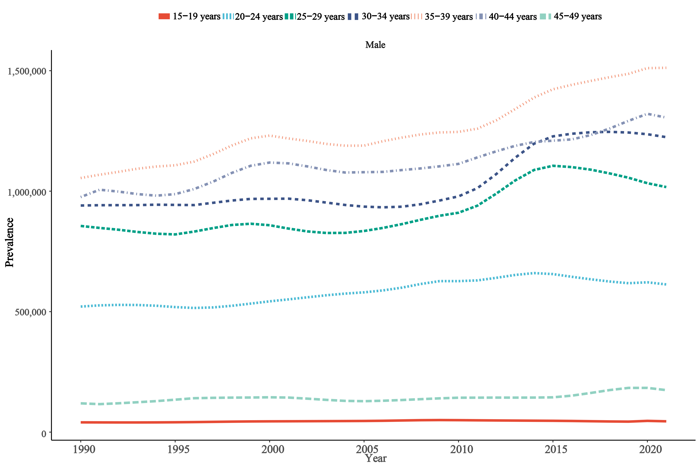

Supplementary Fig. 1. Age-specific male infertility burden in high zone.

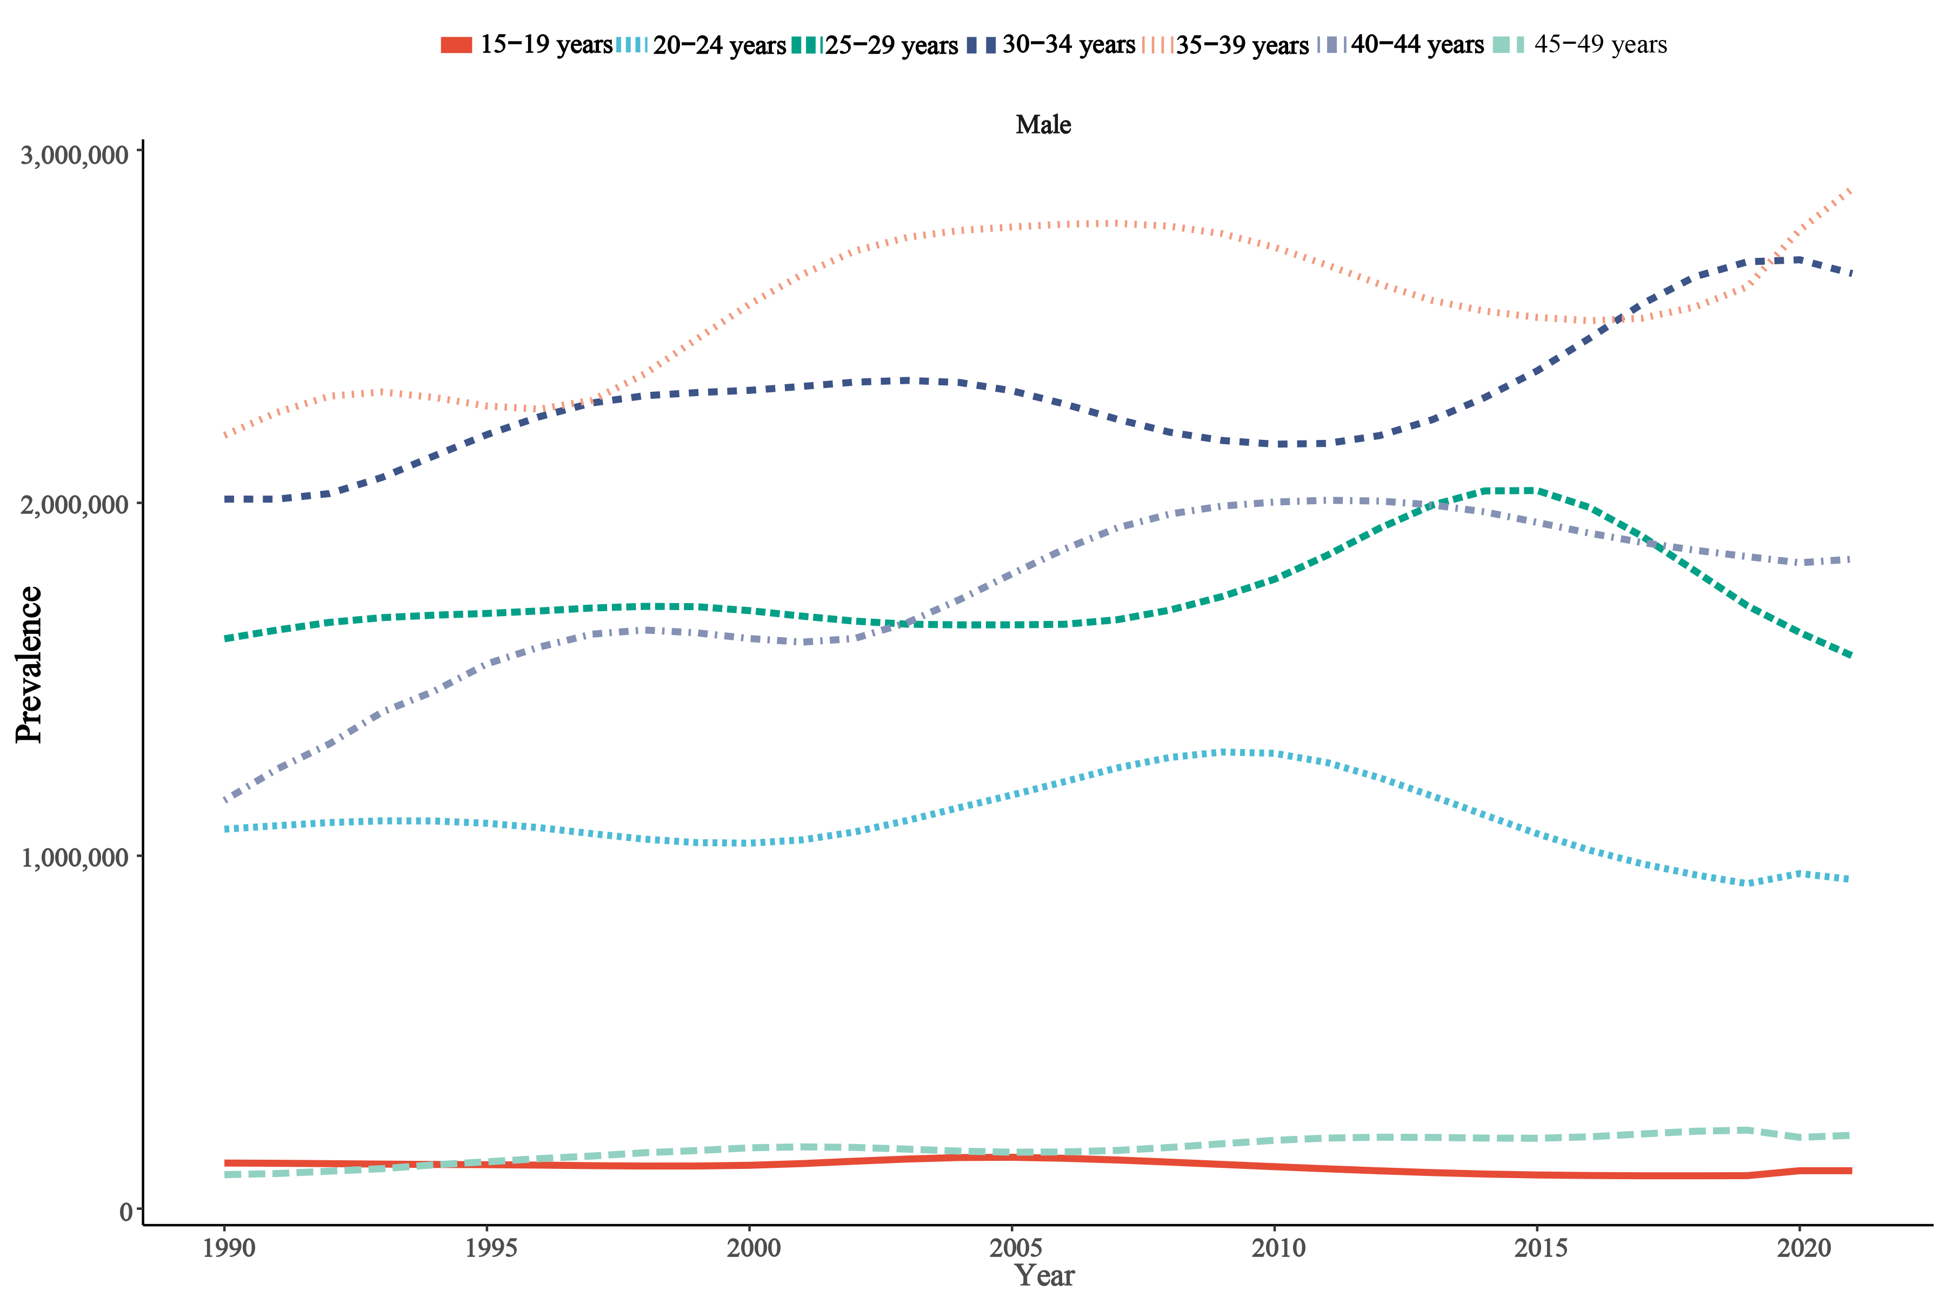

Supplementary Fig. 2. Age-specific male infertility burden in high-middle zone.

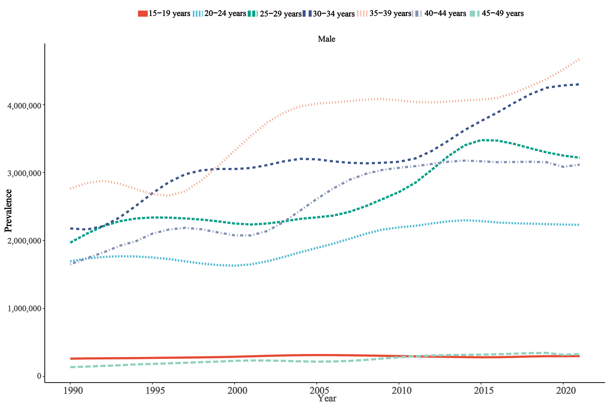

Supplementary Fig. 3. Age-specific male infertility burden in middle zone.

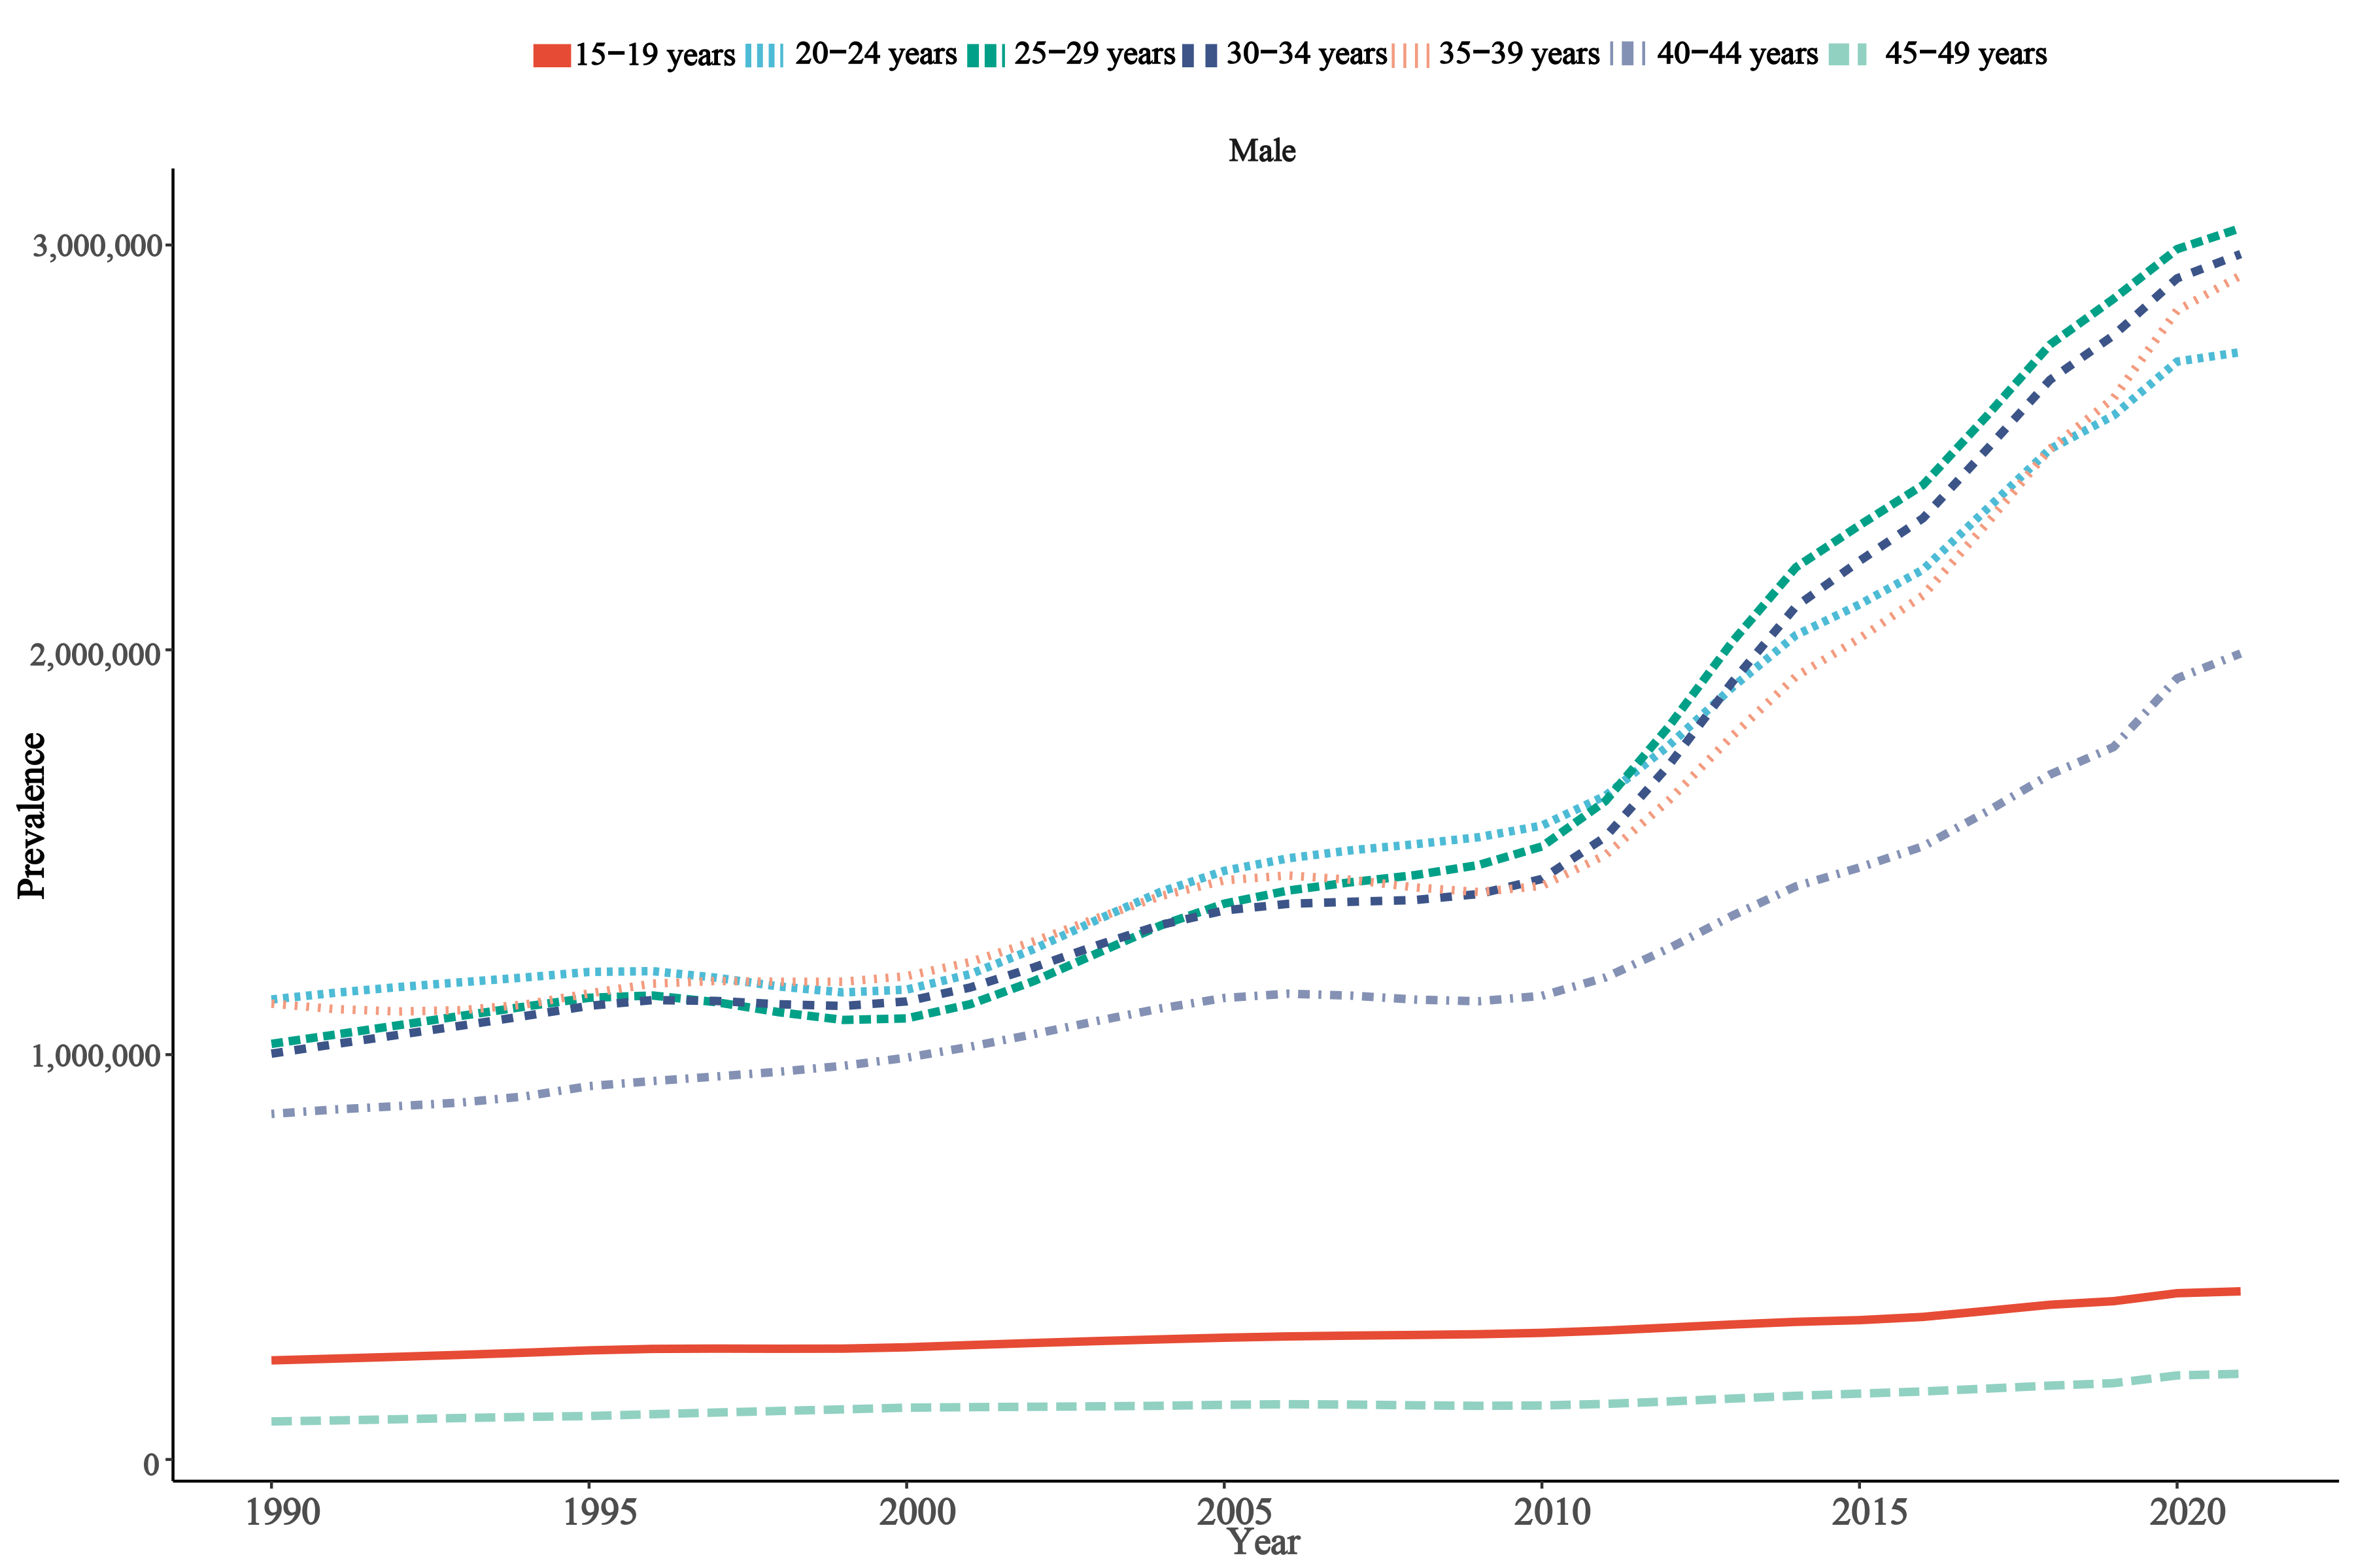

Supplementary Fig. 4. Age-specific male infertility burden in low-middle zone.

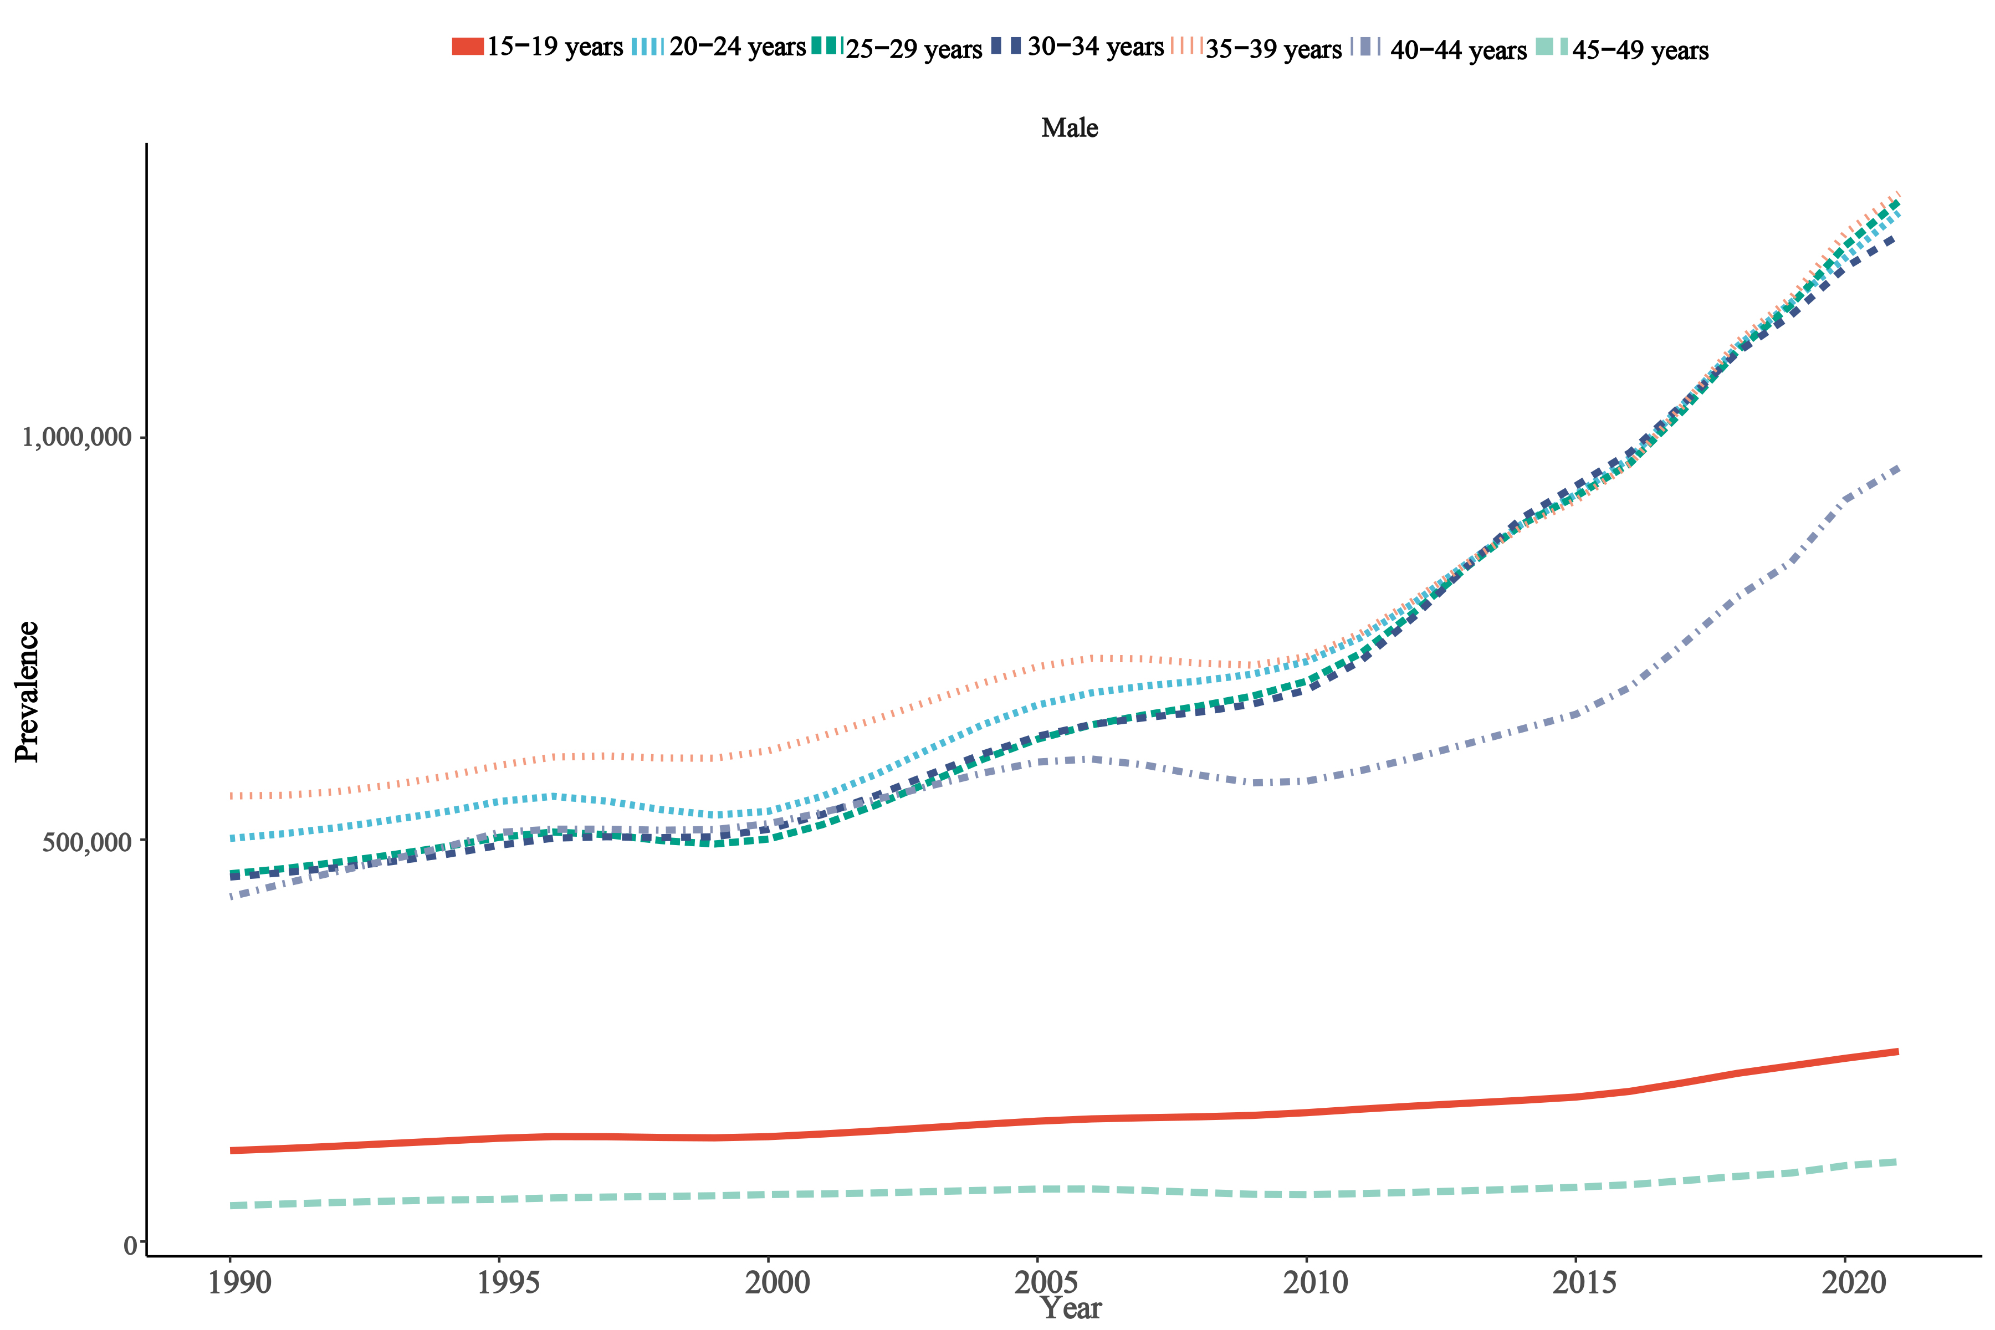

Supplementary Fig. 5. Age-specific male infertility burden in low zone.